What Your Lumber Dealer Won’t Tell You About Pressure Treated Wood

Introduction:
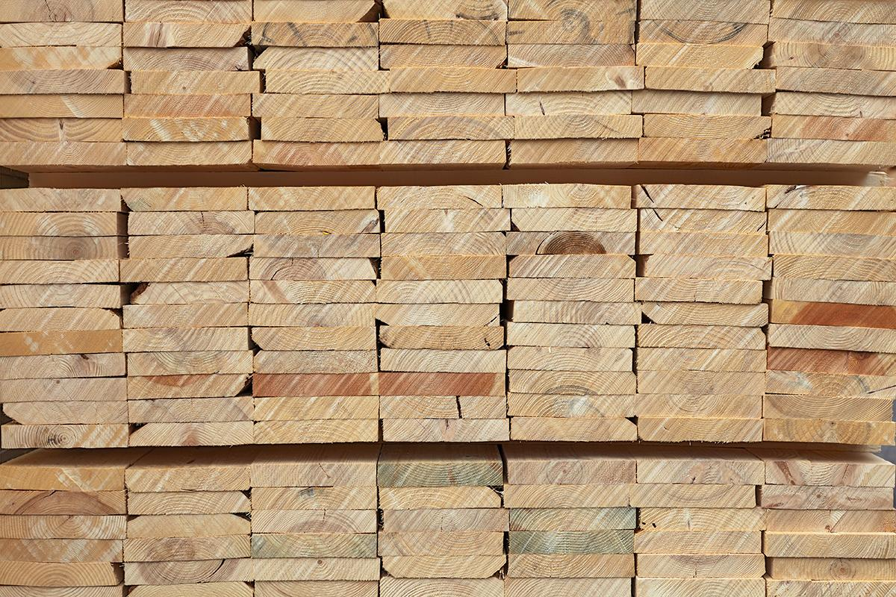

Pressure-treated glulam offers a higher level of stability and durability. But, you don’t always know the whole picture. Your point of contact at the lumberyard may not be a structural engineering expert and may only tell you parts of the story when it comes to your glulam needs.

In the following white paper, we’ll break down what your dealer might not be telling you when it comes to:

- Recent standards updates for general use
- Decay prevention methods
- Preservative treatment requirements
- Maintenance scheduling
- Coastal building compliance

Recent Standards Updates:

Because of its general usage on a building’s exterior, pressure-treated glulam requires a special type of care to ensure its integrity for years to come.

In 2016, The American Wood Protection Association revised wood treating standards to require sawn lumber and timber used in above ground exposed conditions be preservative treated at the UC4A level, just like general ground contact use conditions. Preservative-treated wood used as joists and beams is difficult to maintain, repair, and replace, and is critical to the performance and safety of the entire system/construction. It is the responsibility of the designer and or builder to determine the proper treating specification, given the intended use and environment.

Avoiding Decay Through Design:
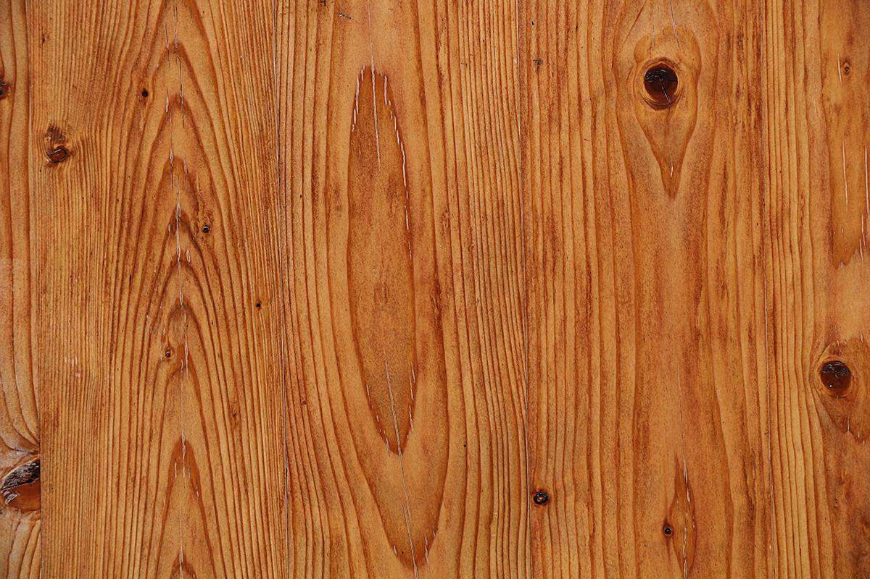

Pressure treated wood is not entirely immune to rot and decay. Thoughtful design detail and construction practices will extend the life of any structure. Decay growth in wood requires prolonged conditions where wood moisture content is in excess of 20%. In wood construction, limiting moisture is the primary method of preventing decay fungi growth.

The permanence of timber structures is best attained by keeping the wood dry. Wood kept below 20% moisture and protected from insect attack will last indefinitely. Proper design includes:
· Good ventilation and air circulation and details that allow water to shed off
· Joint details to prevent moisture entrapment
· Adequate flashing that sheds water
· Details that allow moisture to wick out of the end grain of the member

Poor design can create collection zones for organic matter, such as dirt and leaves, that can cause moisture to collect and become trapped. Organic matter can collect in cracks and in between poorly detailed or flashed connections creating a perfect environment for fungi growth. At the design stage, every effort should be made to allow for good ventilation and air circulation and details that cause water to shed off - this is particularly critical at connections.

Using Preservative Treatments:

Preservative treatment creates an envelope of protection along the surface of the wood. Field fabrication involving cutting through the treated envelop or drilling after treatment breaks this envelope, exposing untreated wood to attack by decay, fungi, and insects. Decay potential in field-drilled holes and sawn surfaces can be reduced with proper field treatment of the cut surfaces during construction. However, wood treated in the field is less resistant to decay than wood treated by pressure processes.

Where possible, fabrication or machining should be performed prior to treatment. All field cuts, holes, or beam damage that occurs after treatment must be field treated to protect the exposed wood material. Application of a copper naphthenate solution having a minimum 2% metallic solution is specified in accordance with AWPA Standard M4.

When to Do Periodic Maintenance:
Although pressure-treated wood can be protected against rot (fungal decay) and termites, periodic maintenance must be performed to maximize protection against weathering. Exposed wood should be protected with a high quality water-repellent finish or stain to help reduce warping, checking, and splitting.

All buildings should be inspected periodically to make sure that roofs and downspouts are functioning properly and wood is not being inadvertently subjected to excessive moisture. Water from leakage or improper drainage can elevate the moisture content of treated and untreated wood promoting decay.

Moisture retaining debris can collect between deck boards and in the gaps in connections. Periodic cleaning of this debris from between wood members, especially at the end grains, allows drying to proceed and inhibits decay.

Larger timbers can also be vulnerable to checks, splits, and other weather-related problems. The best way to maintain larger timbers is to keep water away from joints, end grain surfaces, checks, and splits.

Connections of deck band boards to the structure should be inspected periodically for moisture intrusion. These conditions frequently leak from wind-driven rain and moisture accumulation. Leakage can occur at the flashing to structure interface or at the bolts connecting the band board to the structure.

Building Along the Coast:

Buildings constructed in the coastal environment require a higher level of design and construction detailing than structures built inland away from high wind, driving rain, as well as corrosive salt spray and high humidity. Design professionals and builders need to understand the local conditions and provide detailing that addresses those unique challenges. Best building practices need the designer and builder to consider how moisture will impact the structure during its service life.

Conclusion:

No building material is perfect. When talking with a lumber dealer, ask questions. Answers about decay, maintenance, coastal building codes, preservatives, and overall building standards are critical to the success and durability of your project.

CTA Box: Contact an engineered wood expert today!

