Sustainable Building on a Budget

INTRODUCTION

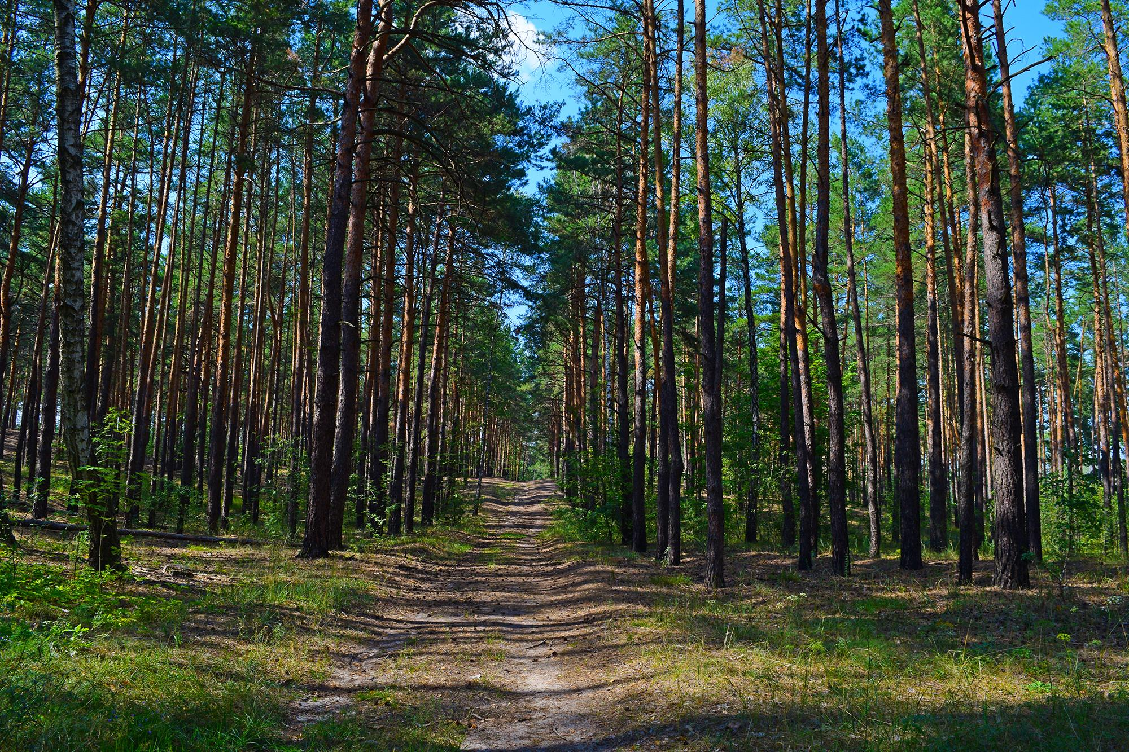
In the following white paper, we will discuss the numerous environmental benefits of glulam, including how its carbon footprint stacks up against steel and concrete.

According to the American Institute of Timber Construction, glulam is one of the most sustainable building products on the market today.

Environmentally sustainable architectural design is nothing new.

According to the American Wood Council, the glulam industry has weathered unprecedented economic changes. Specifically, the economic recession of the previous decade led to a bigger focus on using more economically-friendly materials. Previously, a focus on the environment was not necessarily top of mind, which led architects and builders to lean on traditional materials like steel and concrete.

Mark Scambray with Structural Resource Group says there is a move back toward the forest as the housing and construction markets recover. “Finding ways to build better while saving money just makes good sense,” he explains.

Section One: Life Cycle Comparisons

Glulam manufacturing derives about 45% of its energy consumption from renewable energy sources, meaning glulam leaves a low carbon footprint when compared against traditional building materials like steel and concrete.

According to the Environmental Product Declaration from the American Wood Council, the forest operations portion of the life cycle relies heavily on diesel fuel used by heavy machinery.

However, a significant portion of the manufacturing energy requirements are met by renewable energy sources, including 39% from biomass and 1% from hydro power.

Graph One: Life Cycle of Glulam (courtesy American Wood Council)
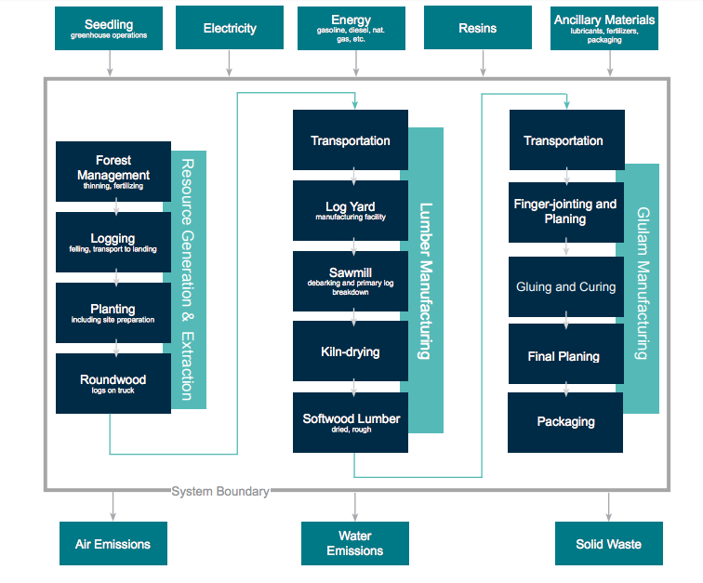

Graph 2: Cradle-to-Gate Impact Assessment Results (courtesy American Wood Council)

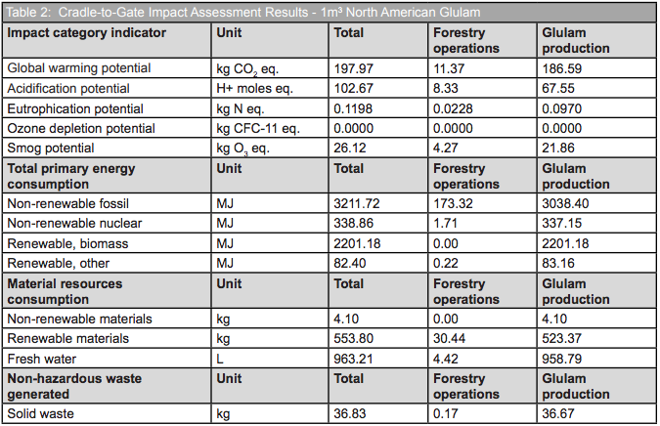

The EPD goes on to show that, “biomass consumption is used exclusively in the upstream kiln-drying process in lumber manufacturing, while the hydro energy use is due to electricity that is consumed throughout the cradle-to-gate product system.”

According to UK-based International Timber, “Reducing the carbon footprint of any building or structure is important, with architects and specifiers always on the lookout for products and techniques that can reduce a building’s environmental impact. While glulam beams do use energy through their production, when compared to the energy used in steel and concrete beam production, they are the better choice.”

Section 2: Carbon Sequestration

Carbon sequestration is part of the natural life cycle of trees. This occurs when atmospheric carbon dioxide is stored in trees, branches, foliage, and roots.
According to the U.S. Department of Agriculture, “The sink of carbon sequestration in forests and wood products helps to offset sources of carbon dioxide to the atmosphere, such as deforestation, forest fires, and fossil fuel emissions.”
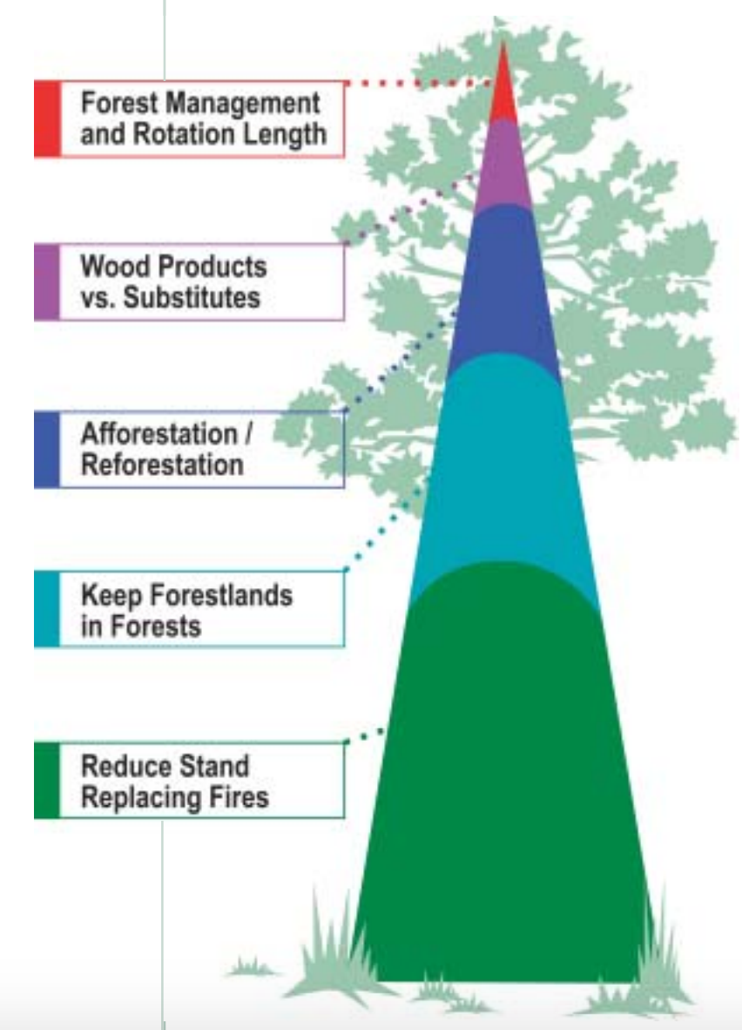
Chart courtesy Oregon Department of Forestry, 2006
The Oregon Department of Forestry says scientists have studied reforestation and how companies like Rosboro can aid in carbon sequestration or reducing greenhouse gas emissions.
Dr. Jim Bowyer with the University of Minnesota compared the construction of a Swedish apartment building. The space was constructed twice - once out of concrete and once out of wood. Bowyer found concrete to use 22% more energy for construction and more than double the CO₂ emissions of wood. Bowyer concluded, “the average greenhouse gas mitigation from wood construction over a century is 2-3 times better than concrete. Wood is a more effective means of reducing fossil fuel use.”
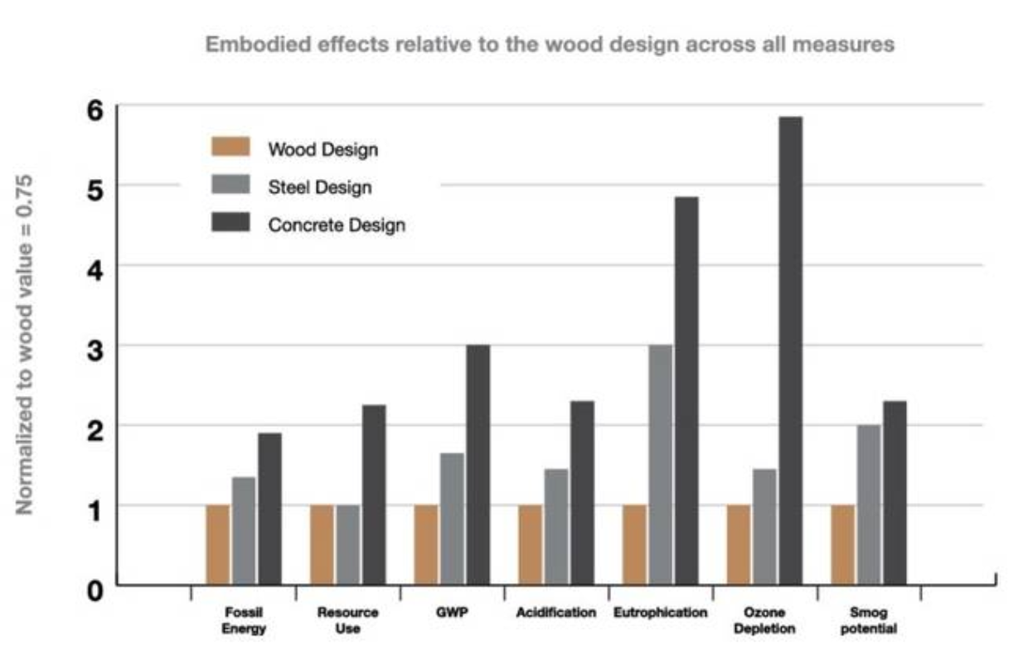
Chart courtesy Treehugger.com
Section 3: Why Choose Green Vendors
Wood use in construction offers numerous benefits to a project’s stakeholders, particularly architects and builders.
- Innovative approaches: Lumber companies are embracing radio frequency beam curing equipment to diminish the use of fossil fuels while speeding up process times.
- Second- and third-generation tree use: Adhering to state-regulated reforestation best practices means using newer trees to create engineered wood products. This keeps the carbon footprint lower by promoting sequestration through older and larger trees.
- 100% usability: Any lumber dealer can use 100% of what they cut in some fashion.

Section 4: Government Aid to the Industry
In buildings 7-15 stories tall, researchers believe using emerging wood technologies like glulam could have the same emissions control impact as taking more than 2 million cars off the road for one year. The Timber Innovation Act currently making its way through Congress would encourage code changes to allow for more mass timber building projects.
Conclusion:

Wood structures are scientifically proven to use less natural resources and have less of an environmental impact, when compared to steel and concrete. Engineered wood products don’t require the same use of fossil fuels to produce or construct. Timber usage goes well beyond the environment, with a growing marketplace to encourage the use of mass timber for larger-scale structures.
CTA Box: Contact an engineered wood expert today!

About:

Rosboro is the premiere leading integrated forest products company in the United States. Located in the Pacific Northwest, Rosboro is committed to manufacturing top-quality glulam products and selling them through a nationwide distribution network. Glulam is the most cost-effective engineered wood product on the market today, making it the best choice for flooring, roofing, and wall framing.

Sources:

U.S. Department of Agriculture - https://www.usda.gov/media/blog/2014/10/10/announcing-us-tall-wood-building-prize-competition-innovate-building
American Wood Council
“Forests, Carbon and Climate Change: A Synthesis of Science Findings,” Oregon Forest Resources Institute, Oregon State University College of Forestry/Oregon Department of Forestry, Published 2006
Oregon Department of Forestry Best Practices
Treehugger.com
International Timber United Kingdom
“Carbon Implication of Construction Materials Selection,” Dr. Jim Bowyer, University of Minnesota and Dovetail Partners
https://archpaper.com/2017/05/timber-innovation-act-gains-support-congress/

